Paper Prototype suggestions



One Idea was to take note cards and cut them into squares to represent tiles in unity with numbers written on them to indicate how many tiles high it is. The note cards could then be partially colored to indicate slime, the player is a plastic bottle cap with smaller colored note card squares to represent the slime you are carrying.

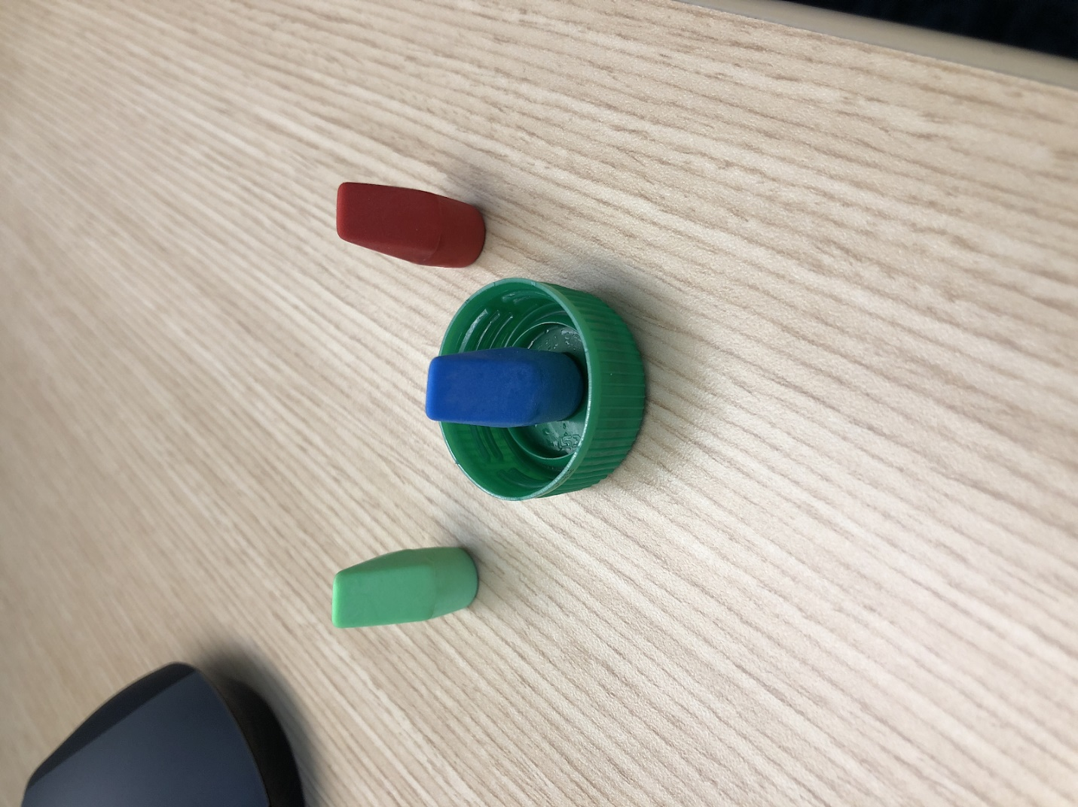

Green bottle cap ( Player) erasers (Slime)